Trees in C
Objectives
The objectives of this session are to consolidate your understanding of binary tree manipulation.
Reference Material
This practical session is based on the Trees chapter, concentrating in particular on how to generate a binary tree.
Overview
There are two source files to consider both found in the trees directory, the first is storint.c which contains all the code from the chapter and implements a binary tree of integers. The other file to consider is freq.c which contains code to prompt for a file, open it for reading and break it into words. This is the same code used in the “Searching and Sorting” and the “Linked lists” practicals.
Practical Outline
Once again in the freq.c file, the process() function breaks the input file into separate words. Each word from the file is read via the getNextWord() function into a character array. Build up a binary tree of words using the code in storint.c. Just as with the linked list exercise, don’t put a fixed size character array into the nodes, instead use a char* and dynamically allocate the storage for each new word.
Thus, the four words “how now brown cow” would build a tree as follows:
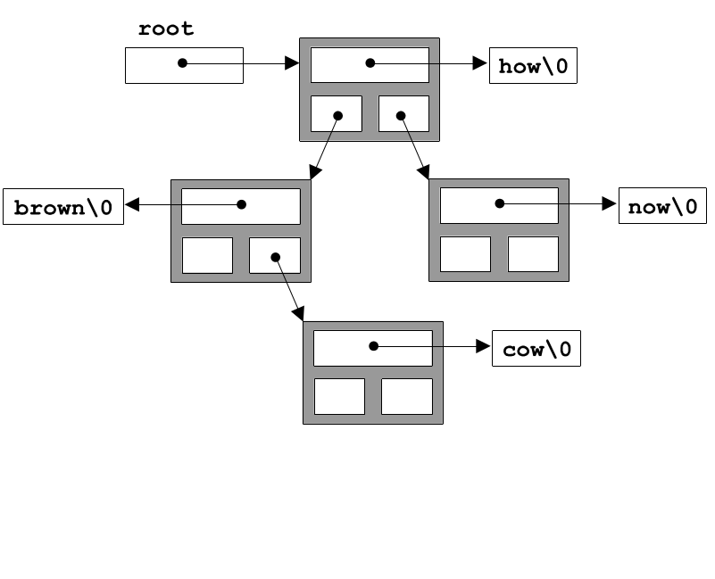
You can use the text file long.txt as trial input. When you have the code working you might like to incorporate the timing routines from the arrays practical.
You should find the program is quicker than the equivalent from the Linked List practical. You will remember that this program was quicker still than the equivalent from the Sorting and Searching practical.

